IVEA ImageJ Plugin Software Manual

IVEA Version 2.0

March 6, 2025

Center for Integrative Physiology and Molecular Medicine (CIPMM), Universität des Saarlandes

Kirrberger Straße 100, Gebäude 48, 66424 Homburg



Table of Contents

**I.** IVEA plugin location: 0

**II.** Random burst event: 0

Advance settings dialog 1

Custom model dialog 2

Output results: 2

**III.** Fixed Event Tab: 4

Advance settings dialog 5

Output results: 6

**IV.** Hotspot Area Extraction: 7

Advance settings dialog 8

**V.** ROI multi-measurement plugin: 9

**VI.** Label new data plugin: 10

Labels and available categories: 10

How to label: 11

**VII.** Training using IVEA Python: 12

Main script with GUI 12

Configuration file 12

Note: IVEA generates a log file for each analysis. To replicate the analysis, please open the log file in the output folder of your previous analysis and verify the parameters used.

# IVEA plugin location:

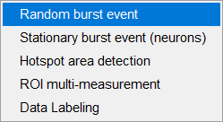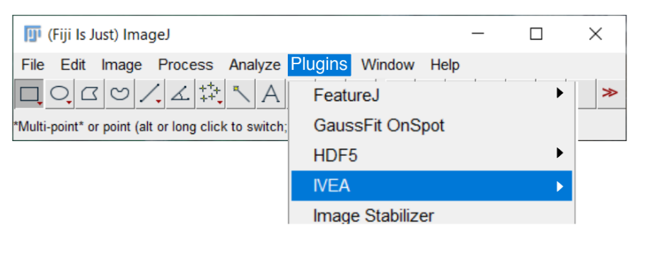Fiji 🡪 Plugins 🡪 IVEA

Figure Fiji-IVEA integration

# Random burst event:

This module is utilized for the analysis of mobile granules, including, but not limited to, T cells, chromaffin cells, INS1 cells, β cells, and others.

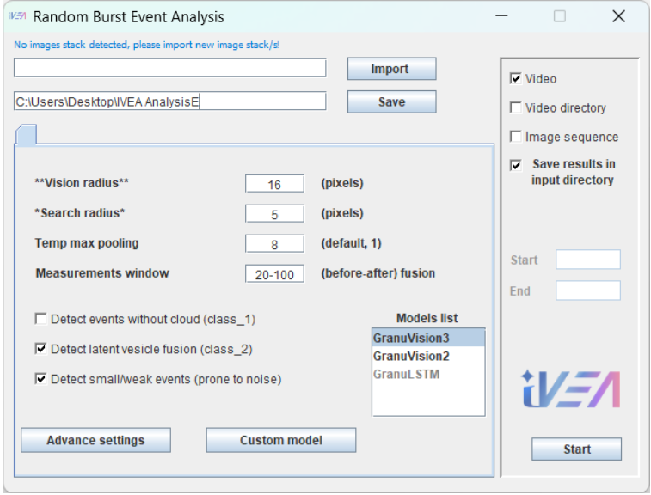

Figure Random Burst Events GUI.

**Vision radius**: is defined as the range within which an activity can be identified. It is the radius for the neural network visualization area (patch size) surrounding an event. This parameter plays a pivotal role in the event classification stage. At each ROI center, IVEA extracts the surrounding area over a time interval, enabling the Transformer neural network to visualize this area. The minimum value for this parameter is 6, and the default setting is 14.

**Search radius**: Size of the ROI radius surrounding an event. (This radius will impact on the results measurements and the non-maximum suppression algorithm)

**Temp max pooling**: Reduce the video frames using temporal max pooling technique (moving maximum intensity projection). This method is typically employed in scenarios where the event’s activity is characterized as slow and exceeds the temporal vision capacity of the neural network (26 or 28 frames), or in instances where the image acquisition frequency is particularly high (e.g., 50 Hz).

**Measurements window**: Measurement time interval from frame a to frame b (a-b).

**Model list**: allow the user to select the current pretrained models available with IVEA for random burst events module. GranuVision3 is an encoder vision transformer model that has been trained on three types of exocytosis: with cloud, without cloud, and latent vesicle fusion (default, model). GranuVision2 is an encoder vision transformer model that has been trained on two exocytosis types: with and without cloud. The GranuLSTM model is an LSTM model; it is no longer supported, but users are free to experiment with it, as it still functions as a general classifier.

**Detect events without cloud**: Include events that undergo exocytosis without exhibiting any observable cloud. (Abrupt disappearance, class/category label is 1)

**Detect latent vesicle fusion**: Include events that undergo exocytosis without exhibiting any observable cloud. (sudden fusion with no previous presence of a vesicle, class label is 2)

**Include small/weak events**: This option enables the software to accept low signal-to-noise events. Default, true.

**Advanced settings button**: Opens a dialog for non-fixed FBE default parameters.

**Custom model button**: Opens a dialog that allows the user to control the export of training data and the use of custom neural networks.

## Advance settings dialog

**Prominence**: The highest minimum surrounding a local maximum. (This value is automatically determined, but users may choose to override it in cases where the signal-to-noise ratio is very low, i.e., p = 30)

**Variation time window**: Subtract frame *n+4* from frame *n*.

**Event spread**: This value can directly influence the non-maximum suppression algorithm. [(see paper)](https://www.biorxiv.org/content/10.1101/2024.08.02.606323v1.full.pdf+html)

**Neural Network Confidence**: The degree of probability or certainty that a neural network assigns to its classification for a given input. (A higher confidence value indicates a lower probability of false positives, although it may result in the loss of some true events, default 0.5)

**Nomination sensitivity**: This option allows the user to adjust the detection threshold sensitivity manually. (User would change this value when, SNR is very low or when the video exhibits regions of non-uniform fluorescence intensity, i.e., regions where cells are very bright and regions with faded cells)

Figure Non-Fixed Event Advance Settings window.

**Gaussian blur**: Use gaussian blur to reduce noise. (default, true)

**Adjust for bleach correction**: Track fluorescence intensity over time. (default, true)

**Disable Log info prompt**: deactivate the IVEA info messages prompt in ImageJ Log window. (default, false)

## Custom model dialog

This dialog enables the user to import custom model, define the classes interested in (exocytosis), and export the training data (Labeled ROIs predicted by the current model used).

## Output results:

Hint: To utilize the ROIs in Fiji with ease, simply click on the ROI manager tool and select the ROI you want. Then, press the Shift key + the arrow keys (left or right). From multi-channel mode Fiji allow the user to add Ctrl and Alt keys. (i.e., Shift + Ctrl + Alt + arrow keys)

Figure Non-Fixed Event analysis output display.

# Fixed Event Tab:

This tab is utilized for the analysis of videos with fixed image acquisitions, such as DRG neurons.

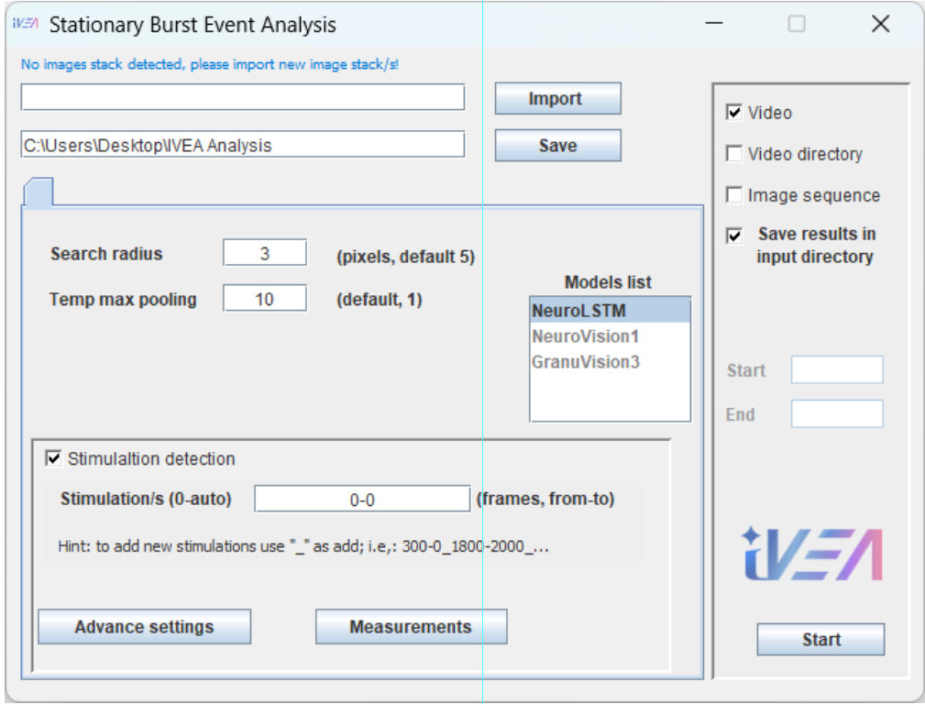

Figure Stationary Burst Events module GUI.

**ROI radius**: Size of the ROI radius surrounding an event. (This radius would impact the results measurements)

**Temp max pooling**: Reduce the video frames using temporal max pooling technique (moving maximum intensity projection). This method is typically employed in scenarios where the event’s activity is characterized as slow and exceeds the temporal vision capacity of the neural network (40 frames), or in instances where the image acquisition frequency is particularly high (e.g., 50 Hz).

**Model list**: allow the user to select the current pretrained models available with IVEA for stationary burst events module. NeuroLSTM is an LSTM model that has been utilized for synaptic neurons, such as exocytosis events. This model is the default model for this type of analysis. NeuroVision1 is an encoder vision transformer model that has been trained on three synaptic neurons exocytosis types: short, long stay, and slow exocytosis. The third model, GranuVision3, is an encoder vision transformer model that is the same module used with the random burst events module and trained on granules. It is imperative to note that the encoder vision transformer network in this module is experimental in nature. This implies that its efficacy has been assessed on a limited dataset, and the optimal outcomes cannot be assured, as the model remains in a state of continuous development and enhancement.

**Stimulation detection**: Is a special feature for analysis with strong simulation to be detected like in DRG neurons.

**Stimulation/s**: Simulation timing from a to b (a-b). a or b are determined automatically if set to 0, “_” is used for more than one simulation. (Is used to detect strong simulation events)

**Advanced settings button**: Opens a dialog for fixed FBE default parameters.

**Measurements button**: Opens a dialog that allows the user to control the measurements to be conducted.

## Advance settings dialog

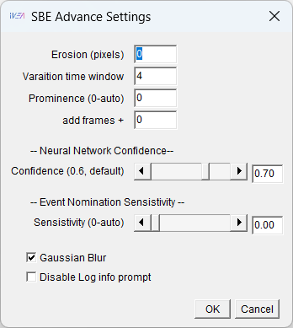**Erosion**: Is the erosion filter. (default, 0)

**Variation time window**: Subtract frame *n+4* from frame *n*.

**Prominence**: The highest minimum surrounding a local maximum. (This value is automatically determined, but users may choose to override it in cases where the signal-to-noise ratio is very low, i.e., p = 30)

**Add frames**: This field allows the user to extend the analysis window time, available only with the LSTM model. [(see paper)](https://www.biorxiv.org/content/10.1101/2024.08.02.606323v1.full.pdf+html)

**Neural Network Confidence**: The degree of probability or certainty that a neural network assigns to its classification for a given input. (A higher confidence value indicates a lower probability of false positives, although it may result in the loss of some true events, default 0.5)

**Nomination sensitivity**: This option allows the user to adjust the detection threshold sensitivity manually. (User would change this value when, SNR is very low or when the video exhibits regions of non-uniform fluorescence intensity, i.e., video contains regions in which the cells exhibit a high signal intensity, as well as regions in which the cells display a low signal intensity in the same frame.)

Figure Fixed FBEs advance settings window

**Gaussian blur**: Use gaussian blur to reduce noise. (default, true)

**Disable Log info prompt**: deactivate the IVEA info messages prompt in ImageJ Log window. (default, false)

## Output results:

Figure Fixed Event analysis output display.

1. 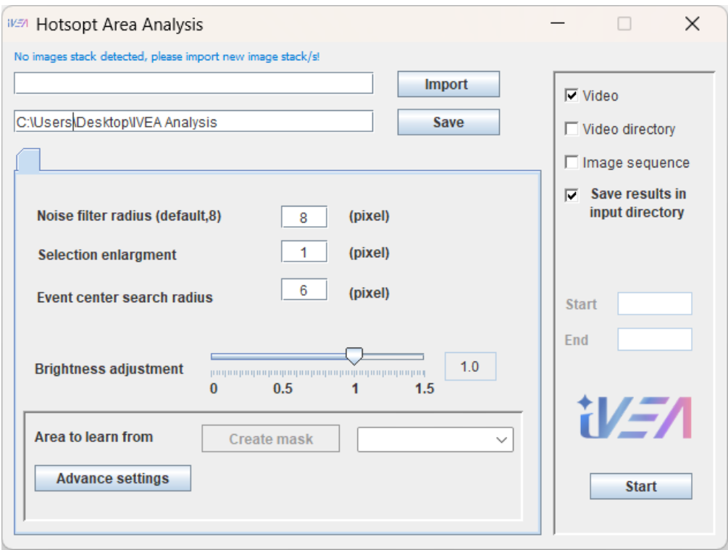Hotspot Area Extraction:

Figure Hotspot Area Extraction module.

This tab is utilized for the analysis of videos with fixed image acquisitions, such as AndromeDA nanosensor paint.

**Noise filter radius**: uses median filter to eliminate noise for the iterative global threshold. (default, 8)

**Selection enlargement**: enlarge the ROI by “n” pixels.

**Event center search radius**: spatial tracking radius.

**Brightness adjustment**: This value controls the fluorescence intensity fluctuations multilayer intensity correction (MIC) algorithm. (User would put this value to 0 if no fluctuations is taking place)

**Create mask button**: Enables the user to select a region on the video/s so that the software would try to learn noise from. (don’t select area with events may occur in)

**Advanced settings button**: Opens a dialog for hotspot area extraction default parameters.

## Advance settings dialog

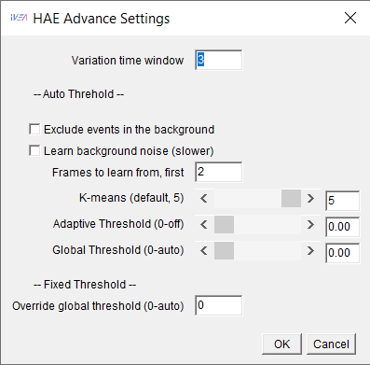**Variation time window**: Subtract frame *n+3* from frame *n.*

**Exclude events in the background**: Don’t detect events in the background.

**Learn background noise**: Allow the software to detect the background noise level and learn from it. (This option is disabled by default. In the event of an action occurring in the background, it may influence the sensitivity threshold by increasing it, thereby bypassing weaker events)

**Frames to learn from**: Study the first 2 or more frames.

**K-means clustering algorithm**: This option allows the user to adjust the number of clusters (layers) for image segmentation. (if k = 1, MIC will act like simple ratio equation, user can monitor the result in the result folder for the image segmentation and adjust the k number)

Figure Hotspot Area Extraction advance window.

**Adaptive Threshold**: Allow the user to extract the maximum regions. (default, 0-off)

**Global Threshold:** Is the iterative threshold. (default, 0-auto)

**Override global threshold:** Allow the user to use static threshold. (not recommended)

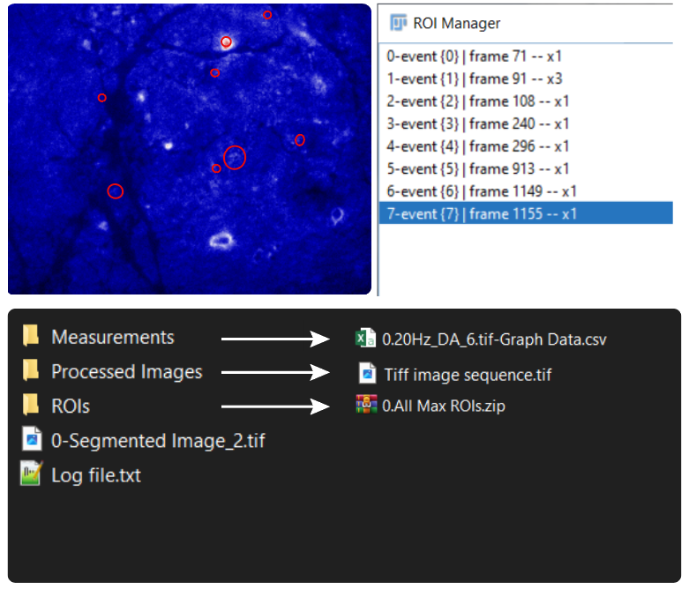

Figure Hotspot Area Extraction analysis output display.

# ROI multi-measurement plugin:

The IVEA Multi-Measurement ROI Plugin is used to measure the profile intensity over the selected ROI(s) in the ROI Manager over a specified time interval. This plugin can perform measurements on single channel opened video(s) or multi-channel selected opened video. This plugin is a helper plugin that can be used to study and analyze the fluorescence intensity profile of the IVEA detected events or any ImageJ ROI.

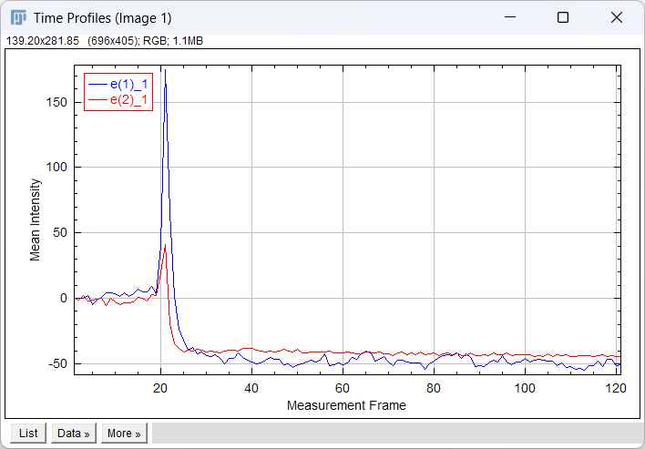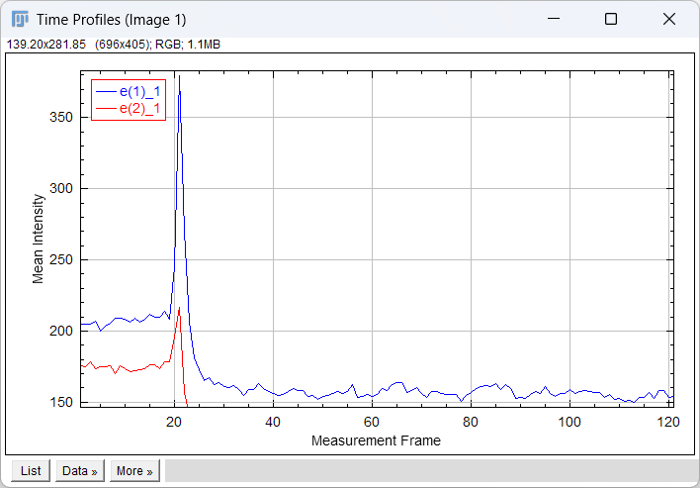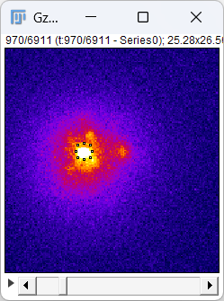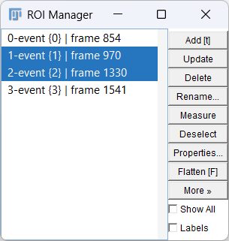

# Label new data plugin:

The IVEA Data Labeling Plugin is used to label data for new training or training refinement.

## Labels and available categories:

Current exocytosis labels: positive integer

“0” for fusion with a cloud.

“1” for fusion without a cloud.

“2” for latent vesicle fusion.

Current noise/artifact categories: negative integer

“-1” random noise.

“-2” vesicle intensity fluctuation.

“-3” moving vesicle.

“-4” random noise with intensity fluctuations.

“-5” intensity flickering and out of focus artifact.

“-6” intensity rise (vesicle docking).

“-7” intensity decrease (vesicle undocking).

“-8” light movement such as a passing light or cloud spread away from the vesicle as a wave etc..

These labels are directly controlled by the IVEA JSON configuration file available with the Python training project. Users have the capacity to modify these labels to add new categories. Additionally, expert users possess the capability to adjust the labeling of a new dataset or to manipulate an existing dataset.

## How to label:

The user can navigate through the ROIs in the ROI Manager using the up and down arrow keys, select the desired ROI(s) and press Enter. This will open a new dialog box to enter the class number and press Enter again to label - Escape to close. The user does not need to move the mouse and click, most commands are controlled by keyboard shortcuts. Positive integers reflect the labeling of fusion events (i.e., 0,1,2, etc..), while negative labels correspond to the noise/artifact categories (i.e., -1,-2, etc..).

labeled

# Training using IVEA Python:

The “IVEA_main” script is the main script responsible for running the IVEA Python GUI.

## Main script with GUI

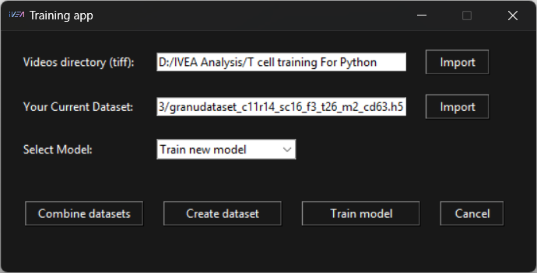

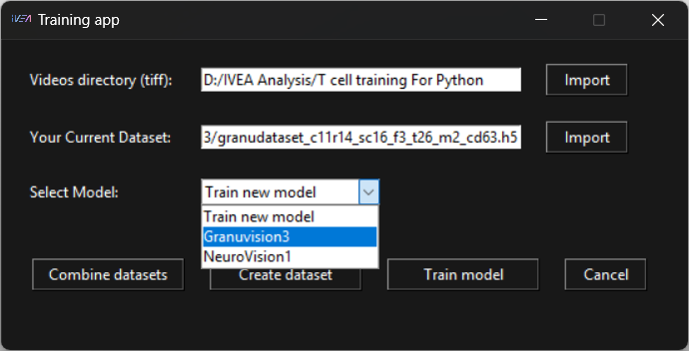

## Configuration file